**Case 2:**

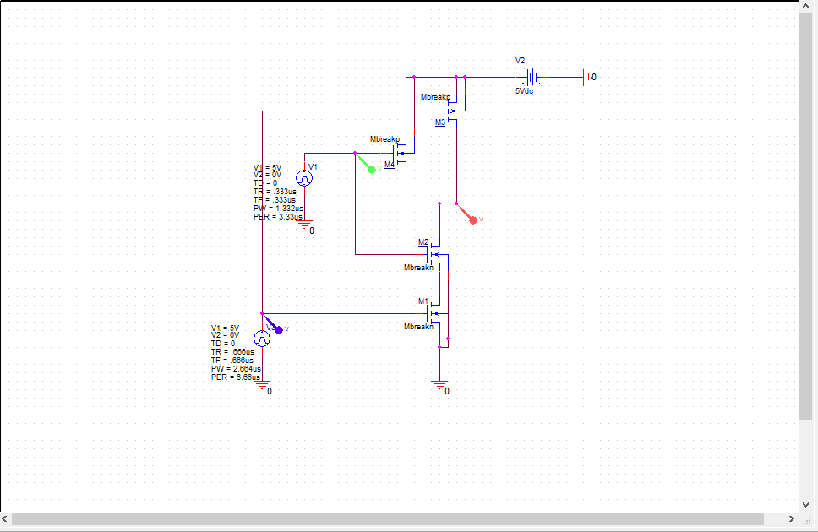

**Figure 1: Circuit Schematic for 5V squarewave, f = 300kHz**

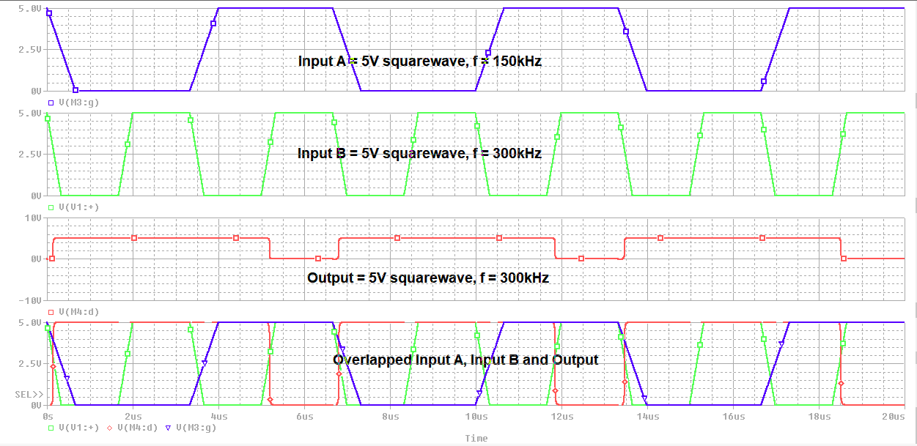

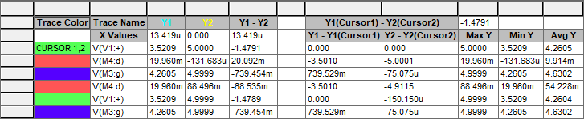

**Figure 2: Output waveform for 5V squarewave, f = 300kHz**

**Case 4:**

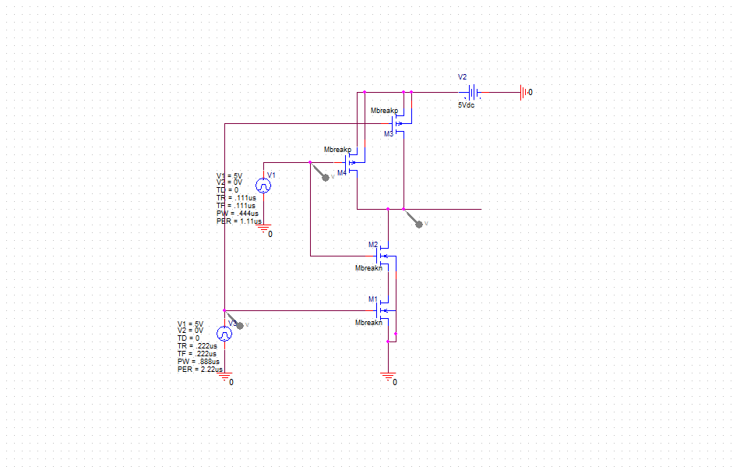

**Figure 3: Circuit Schematic for 5V squarewave, f = 900kHz**

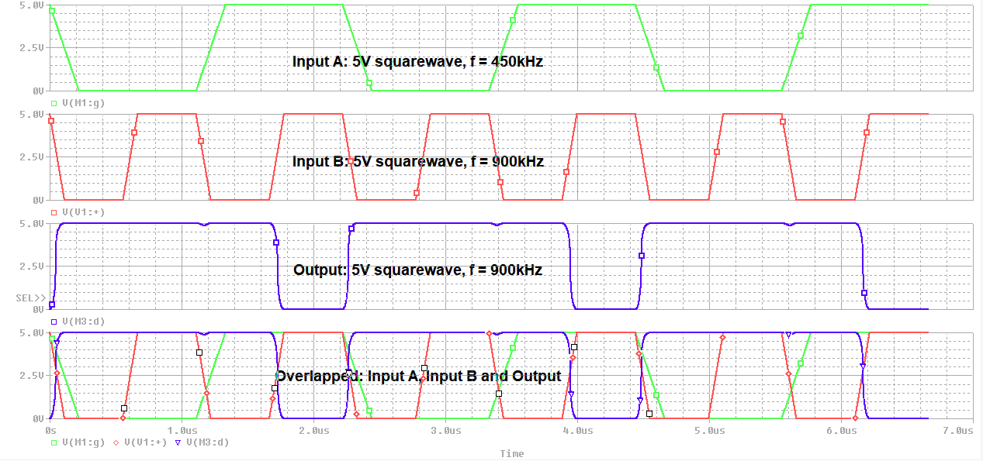

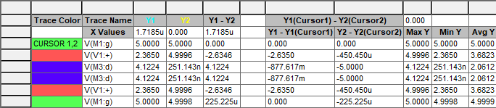

**Figure 4: Output waveform for 5V squarewave, f = 900kHz**

**Ramp Case:**

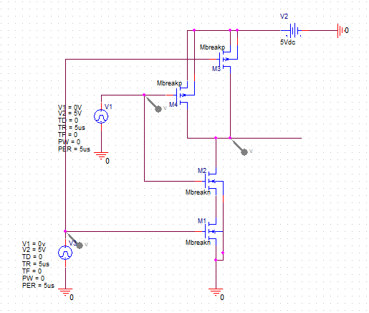

**Figure 5: Circuit Schematic for 5V Ramp Case, f = 200kHz**

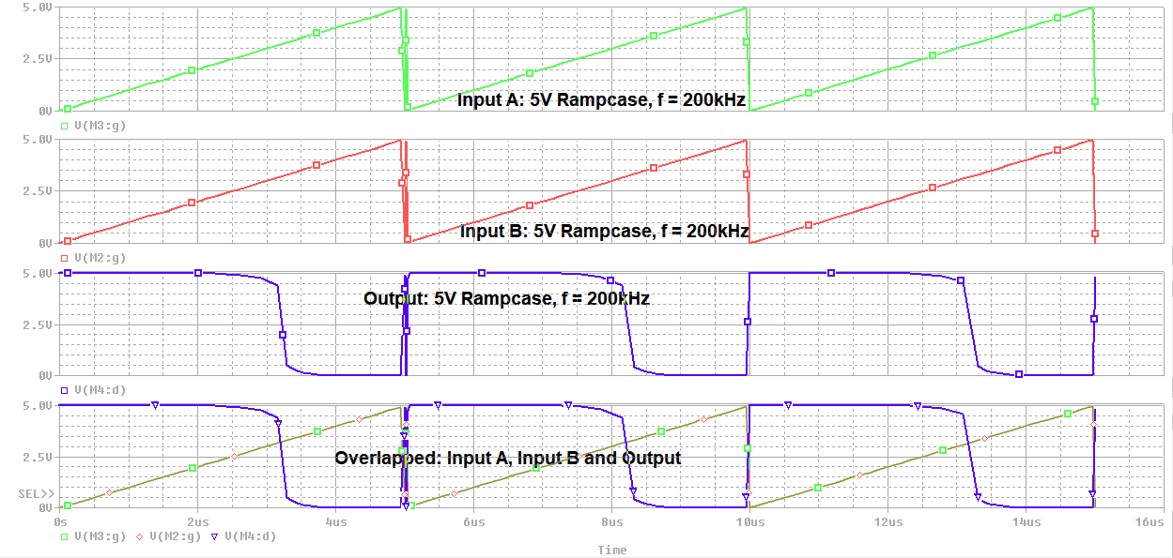

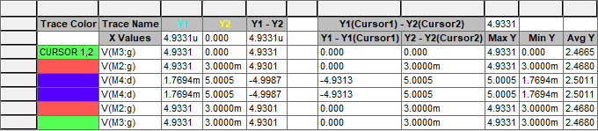

**Figure 6: Output waveform for 5V Ramp case, f = 200kHz**

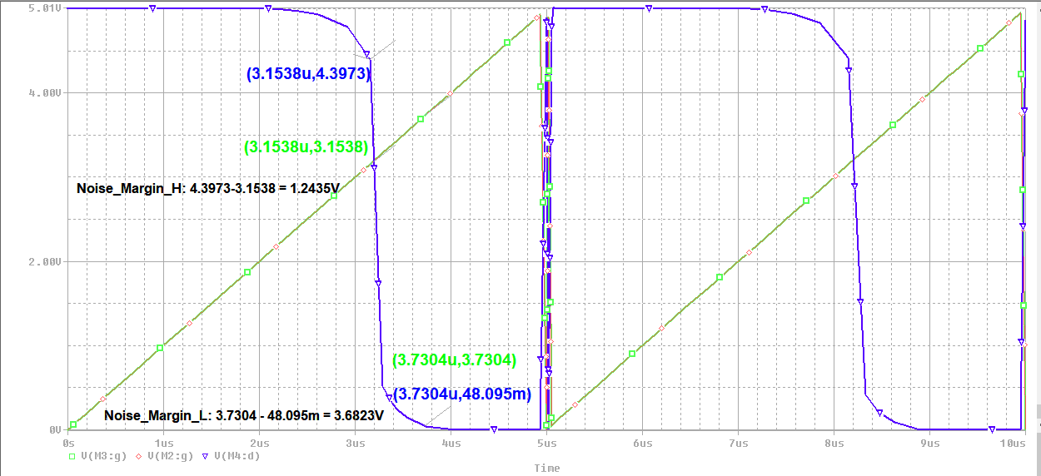

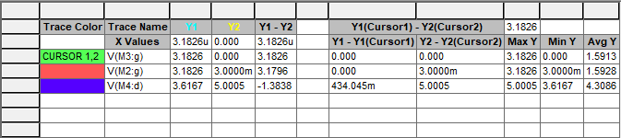

**Figure 7: Noise Margin waveform for ramp case, f = 200kHz**